USER INTERFACE DESIGN
EXP 2
Introduction: Chunking is a cognitive strategy that involves breaking information into smaller, meaningful units. This experiment uses a game-based UI to analyze how chunking improves short-term memory recall by presenting visual elements within a limited time.
FRAME 1: INSTRUCTION PAGE:
Chunking & Word Recall
The instruction page introduces the task using clear chunking principles.
Instructions:
- Observe the words shown on the screen.
- Words will be grouped into meaningful categories.
- Memorize the words within the given time.
- Recall the words by selecting the correct ones.
- Accuracy is more important than speed.
UI Design Elements:
- Bold title
- Numbered steps
- START button
- Time limit clearly mentioned
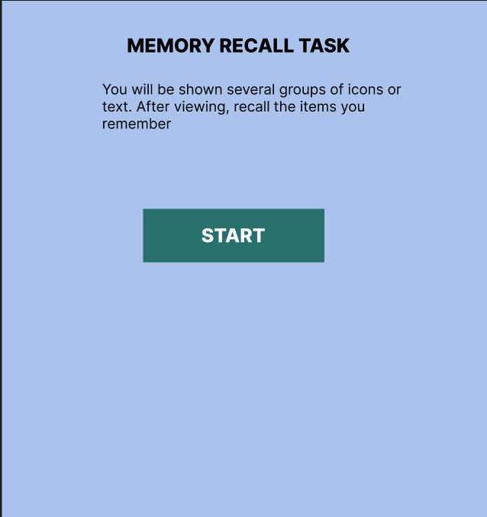
FRAME 2: CHUNKING PHASE (MEMORIZATION)
Analysis of Chunking Phase
Purpose:
This phase allows users to encode information by grouping related words.
UI Elements:
- Countdown timer (8–10 seconds)
- Progress bar
- Word cards grouped by category, such as:
  - Fruits (Apple, Banana, Mango)
  - Animals (Dog, Cat, Lion)
  - Colors (Red, Blue, Green)
Working:
Users observe word groups and form mental chunks based on categories.
Cognitive Benefit:
Chunking improves memory by reducing the number of individual items to remember.
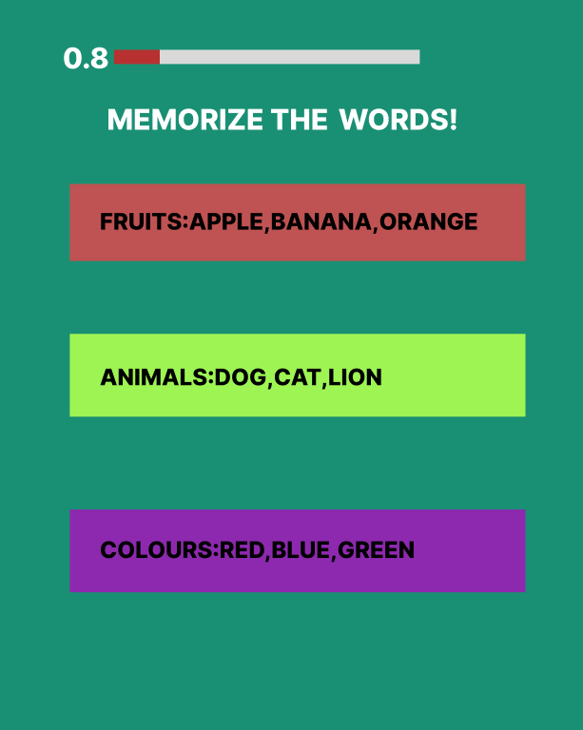
FRAME 3: RECALL PHASE
Analysis of Recall Phase
Purpose:
Tests how effectively users remember chunked word groups.
UI Elements:
- Instruction text
- Mixed word grid containing:
  - Previously shown words
  - New distractor words
- Checkbox or radio button selection
- Submit button
Working Principle:
- Users recall words from memory.
- Identify correct words.
- Distractors test recall accuracy.
- Submission leads to result evaluation.
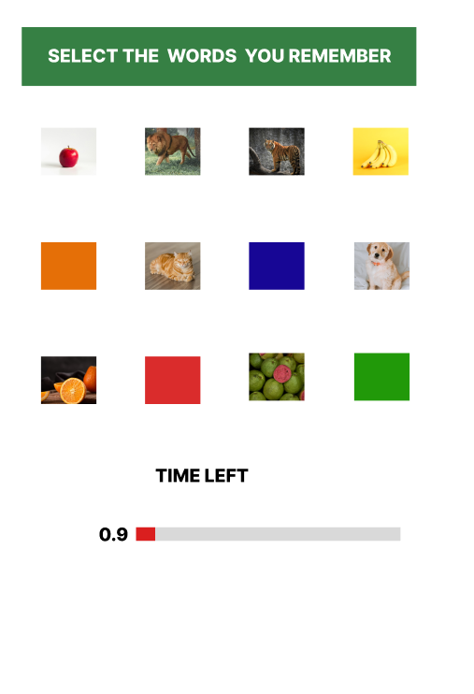
FRAME 4: RESULT PAGE
Analysis of Result Page
Purpose:
Displays memory performance and reinforces learning.
UI Elements:
- Score display (e.g., 7/9 correct)
- Feedback message
- Action buttons:
  - Play Again
  - Home
Cognitive & UX Benefits:
- Immediate feedback improves learning
- Gamified scoring increases engagement
- Simple navigation enhances usability
